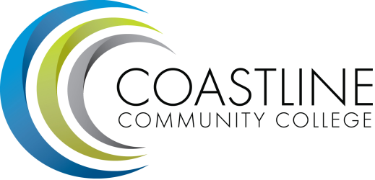
Accreditation Steering Agenda
12/07/17
1:00 pm - 3:00 pm
College Center 4th Floor Conference Room

Committee Mandate: To guide the College through the self-evaluation process for the purpose of continuous self-improvement as evidenced by the Institutional Self-Evaluation Report.

- CALL TO ORDER
  - Roll Call
  - Welcome
  - Adoption of Agenda
  - Minutes from 11/2

- SPECIAL REPORTS & UPDATES
  - Status of Draft Report (D. Pittaway)

- ACTION ITEMS

- STANDING REPORTS
  - Standard I (chairs)
  - Standard II (chairs)
  - Standard III (chairs)
  - Standard IV (chairs)

- DISCUSSION ITEMS
  - Completion of Draft Report
  - Quality Focus Essay – Guided Pathways

- ANNOUNCEMENTS (1-2 minutes per)

- ADJOURNMENT

- Next meeting will occur Thursday, February 1st, 1:00-3:00 pm, 4th floor conference room @College Center. Meeting schedule is 1st and 3rd Thursdays at 1:00 pm during fall and spring terms for 2017-2018.

- Our goal for spring 2018 will be to develop a complete second draft of the self-study report. The final, constituency-approved report is due to ACCJC December 2018.

- Google Accreditation Writing Space

